Blackjack: Project Specification

1. Class design, data and state
Class | Purpose and fields
LinkedChain<T> | Store entries of type T in a singly linked chain. Fields: Node firstNode, int numberOfEntries.
Card; Rank, Suit (enums) | Rank is the number, suit is if it’s a heart, spade, etc. These are enums because the fields of a card can only be A2-10,JQK, otherwise we would want it to be a compile error to avoid it turning into a runtime bug.
Shoe | The stack of cards used in a game, cards get deal at beginning and one at a time during the game. Fields: LinkedChain<card> cards, Random rng,
Hand | The cards the player holds. List<Card> cards.
Bankroll | Hold’s the balance and methods for changing the balance and betting. Field: int balance
Round | Describes and controls round outcomes and player choices. Fields: int round, Outcome (enums), int bet, int net change.
GameHistory | Keeps a record of round results in a linked chain. Reports wins and win rate. LinkedChain<String> result
CardCounter | Keeps track of historical cards and calculates probabilities, suggests bet size using Kelly criterion. Fields: int recommendedBet, LinkedChain<Card> seen.
ConsoleUI | Read console entries, reprompts on bad input, prints the game. Fields: Scanner in
Game | Main class, Runs the game, updates state, stops when the player is broke or quits. Fields: Shoe shoe, Hand dealer, Bankroll bankroll, GameHistory history, CardCounter counter, ConsoleUI ui, int round, Hand player.
Why this split. Classes were split with separate roles in mind and, over the course of designing them, were merged when their functions were not different enough to warrant a separate class. Game class runs the game and draws from al the other classes, ConsoleUI is the “messenger” between the player, the running session, and the underlying code. The card counter class does all the math needed to make betting recommendations. Game history stores the player’s record. The round even is the microcosm that determines what happens and also draws on a lot of other classes (updates game history, bankroll, hand, the shoe, etc.). The bankroll is the player’s wealth. The hand uses the card class. The card is the building block for the shoe.

2. System diagram
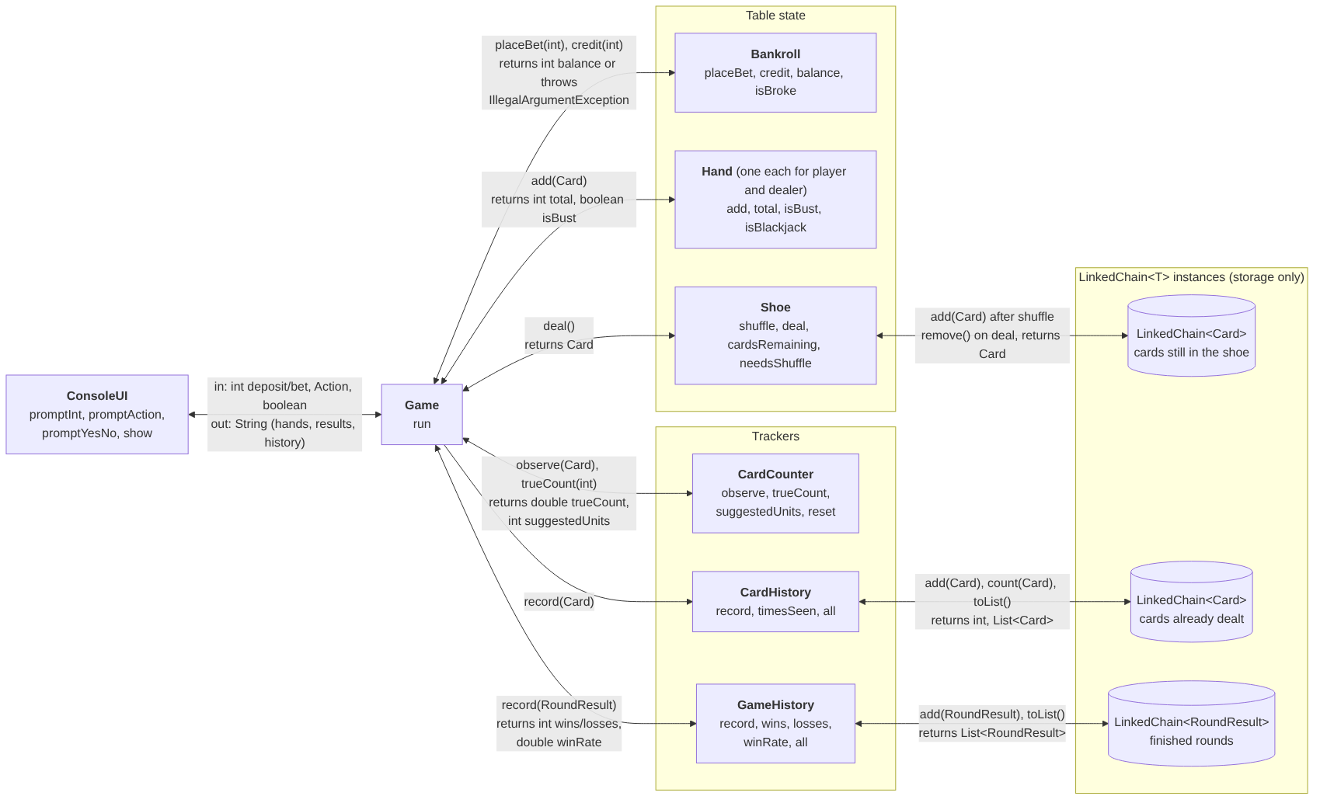

3. The generic contract
T is unbounded. It can and is filled by many types in our program: LinkedChain<Scanner>, <Card>, <String>. The compiler does enforce some promises. Given the field LinkedChain<Card> shoe, shoe.add(“String”) will not compile. Because of this, T promises it will store and return the declared type. It also promises not to store a null type. The rationale for this is avoiding a NPE where code tries to reach for a method in a null variable. The enforcement of the declared type in the linkedchain makes add(), contains(), and remove() take T and return T. Why no bound: we won’t call non-generic methods directly on entries themselves. Any typing work is done at field declaration, where the script tells the compiler that T is.

4. Method signatures and Big-O

LinkedChain<T>
Signature | Behaviour, including edge cases; Big-O and why
boolean add(T e) | adds e at the head, returns true; NullPointerException if e is null. O(1): creates one node, updates only the head reference and size counter
T remove() | Removes and returns the head entry; return null if empty. O(1): only updates firstNode to the next node and decrements the size counter.
boolean remove(T e) | Removes the first matching entry equal to e, returns true; false if none exist. O(n): in the worst case, every node must be checked before finding the entry.
boolean contains(T e) | Returns true if a matching entry exists; false if the chain does not. O(n): in the worst case, every node must be checked before finding a match
int count(T) | Return the number of matching entries e; returns 0 if none exists. O(n): every node must be inspected, since duplicates may be anywhere in the chain.
int size() | Returns the stored number of entries. O(1): numberOfEntries is maintained as a field.
boolean isEmpty() | Returns true if the chain contains no entries; otherwise returns false. O(1): checks whether numberOfEntries == 0 or firstNode == null
void clear() | Removes all entries from the chain. After the call, firstNode is null and numberOfEntries is 0. O(1): resets the head reference and size counter.
toArray(T[] values) | Returns an array containing all entries in the chain, starting from the head. If the provided array is too small, a new array of the same component type is created. O(n): each node is visited, and copied to array.
Changes from standard LinkedChain: None. We plan on using the starter linkedchain as given. The shoe, GameHistory, and CardHistory need add and toArray(T[]), whicha re already there. Add already rejects null, thus remove() is NPE safe.

Constructors and methods
Signature | Behaviour; Big-O and why
Shoe(int decks, Random rng) | Throws IAE if the deck is <1. Otherwise makes an n(decks) * 52 card deck. Makes a temporary arraylist, shuffles it using rng O(n), moves each card into a linkedchain O(n).
Card Shoe.deal() | Removes and returns the head card (headNode); IllegalStateException if none. O(1): removes the head.
int Shoe.cardsRemaining() | Returns cards.size(), O(1): uses the stored size counter
boolean needsShuffle() | Returns true when cardsRemaining() < CUT_CARD. O(1): checks the stored size counter against a constant. The shoe is replaced at the beginning of the next round when this condition is true.
void Hand.add(Card c) | Appends directly; NullPointerException on null. O(1) amortized: Occasional resizing is O(k), but averaged across many additions, it is O(1).
int Hand.total() | Computes the Blackjack total; treating aces as 11, and reducing them to 1 when necessary. An Empty hand has a total of 0. O(k): each card is examined once and at most k aces may need to be adjusted.
boolean Hand.isBust() | Returns whether total() > 21, O(k); uses total(),whichexamines the cards in the hand.
boolean isBlackjack() | Returns true if the hand has exactly two cards totaling 21. O(1): checks the hand size and examines at most two cards
String toString() | Returns a readable representation of the hand and its total. O(k): visits each card once while building the output.
Bankroll(int deposit) | Creates a bankroll with the initial deposit; throws IllegalArgumentException if deposit <= 0. O(1): performs a fixed number of checks and assignments.
int Bankroll.placeBet(int amount) | Subtracts and returns the bet amount; IllegalArgumentException if <= 0 or > balance. O(1): uses a fixed number of comparisons and arithmetic operations.
void Bankroll.credit(int amount) | Adds a payout to the balance. ; 0 is allowed; IllegalArgumentException if negative. O(1): performs one validation check and one arithmetic update.
int Bankroll.balance() | Returns the current balance O(1): directly returns a field.
boolean Bankroll.isBroke() | Returns whether the balance is zero. O(1): performs one comparison.
void GameHistory.record(RoundResult r) | Adds a completed RoundResult to the head of the LinkedChain. Throws NullPointerException if the result is null, leaving the history unchanged. O(1): inserts one entry at the head.
int GameHistory.wins(); int losses() | Count of WIN+BLACKJACK; count of LOSS+BUST; O(n) each: every recorded round needs to be examined.
double GameHistory.winRate() | Returns the fraction of recorded rounds that are wins; returns 0.0 if the history is empty. O(n) counting wins requires one traversal of the history, while obtaining the total number of rounds is O(1)
List<RoundResult> GameHistory.all() | Returns all recorded rounds as a list. O(n): toArray(T[] values) visits & copies every stored round once.
void CardHistory.record(Card c); | Records one dealt card by adding it to the head of the LinkedChain. Throws NullPointerException if the card is null, leaving the history unchanged. O(1): inserts one entry at the head.
List<Card> CardHistory.all() | Returns all recorded cards in reverse chronological order (most recently dealt first). O(n): visits every stored card once.
void CardCounter.observe(Card c) | Records a dealt card for use in the Bayesian probability model. O(1): adds the observed card to the linked chain. The recorded cards are used later to estimate probabilities.
int CardCounter.suggestedUnits(int cardsRemaining) | Uses the Bayesian probability model and observed cards to estimate the probability of favorable outcomes, then applies the Kelly criterion to recommend a bet size.  O(B(n)), where B(n) is the complexity of the Bayesian probability calculation. The Kelly calculation itself is O(1). The exact complexity depends on the probability estimation algorithm used.
int ConsoleUI.promptInt(String prompt) | Reads a line until a valid int is entered; re-prompts when NumberFormatException thrown. O(1) per attempt with repect to game data size, assuming bounded input length. The number of attempts is unbounded because invalid input causes re-prompting.
Action ConsoleUI.promptAction() | Accepts hit/h or stand/s, case-insensitive, and ignores surrounding whitespace: re-prompts otherwise. O(1) per attempt: compares one input string against a fixed set of accepted values.
boolean ConsoleUI.promptYesNo(String prompt); | Accepts y/yes/n/no, re-prompts otherwise, case-insensitive, and ignores surrounding whitespace; prints one line. O(1) per attempt: compares against a fixed number of strings.
void ConsoleUI.show(String s) | Prints one message. O(1) with respect to the size of the game data
void Game.run() | Runs the game session: accepts the initial deposit and plays rounds until the player quits or runs out of money. A Shoe, CardHistory, and CardCounter are initialized at the start. At the beginning of each round, the game checks needsShuffle(). If the number of remaining cards falls below CUT_CARD, the Shoe is replaced and the CardHistory and CardCounter are reset. Otherwise, the existing Shoe and running count are preserved. Each round displays count-based betting advice, accepts a bet, deals cards, processes player and dealer actions, settles the outcome, and records the result. After the session, the game displays the round history.  O(sN + r(B(N) + k) + r), where r is the number of rounds, s is the number of shoe constructions including the initial shoe, N is the number of cards in a shoe, k is the maximum hand size, and B(N) is the cost of Bayesian probability estimation. Each shoe construction takes O(N), each round includes Bayesian estimation and O(k) hand processing, and displaying the final history takes O(r).
Edge cases: If both the player and dealer have natural blackjack, the round ends as a push and the original bet is returned. If only the dealer has blackjack, the round ends and the player loses the bet. The Kelly-based betting recommendation is advisory, and the actual bet must not exceed the available bankroll. A regular win credits twice the original bet, resulting in a net profit equal to the bet. A natural blackjack pays 3:2, with fractional payouts truncated using integer arithmetic. A loss or bust forfeits the bet.

5. Where validation lives
Bad input (from the scope) | Caught where, what happens, and why there
Bet of zero or negative; bet larger than the balance | Bankroll.placeBet() throws an IllegalArgumentException if the bet is zero, negative, or more than the player's balance. Game.run catches it, displays the message, and asks the player to enter another bet.  - Will print “Bet must be greater than zero”
Deposit of zero or negative | Bankroll(int) throws an IllegalArgumentException if the deposit is zero or negative. Game.run asks the player to try again. This is handled in Bankroll because it manages the player's money.  - Will print “Deposit must be greater than zero”
Non-numeric text where a number is expected | ConsoleUI.promptInt catches the NumberFormatException and asks the player to enter a whole number if the player types in letters instead of numbers. (Handled in UI)
Anything but hit or stand at the action prompt | ConsoleUI.promptAction tells the player to type "hit or stand" and keeps asking until they enter a valid response. (Handled in UI)
Hitting when no cards remain | Game.run checks needsShuffle() before each round so the player doesn't run out of cards while playing. Shoe.deal() also throws an IllegalStateException if the shoe is empty.
Balance reaches zero | Game.run checks isBroke() after each round, prints "You are out of money." and the history, and ends. No mid-game deposit.
add(null), remove() on empty | LinkedChain throws a NullPointerException when trying to add null because null values could cause errors when comparing entries. If remove() is called on an empty chain, it returns null because there is nothing to remove.

6. Test plan
One normal case and one bad-input case per public method, written as input, then expected result. “Chain A♠, A♠, K♥” means those three added in that order, so K♥ is the head.
LinkedChain. add: A♠ into empty, size() 1 and contains(A♠) true; add(null), NullPointerException and size still 0. remove(): chain A♠, A♠, K♥ returns K♥ with size 2; empty chain returns null with size 0. remove(T): remove(A♠) on that chain is true and count(A♠) becomes 1; remove(Q♦), which is not there, is false and size stays 3. contains: contains(K♥) true; on an empty chain false. count: count(A♠) is 2; count(Q♦) is 0. size: after three adds, 3; after one add and one remove(), 0. toArray(new card[3]): that chain gives a list of 3 starting with K♥; an empty chain gives an empty list, not null.
Shoe. Constructor: new Shoe(3, new Random(42)) has 156 remaining and each distinct card appears 3 times; new Shoe(0, rng) throws IllegalArgumentException. deal: a fresh shoe returns a Card and 155 remain; the 157th call throws IllegalStateException. cardsRemaining and needsShuffle: after 10 deals, 146 and false; after 125 deals, 31 and true (32 is false).
Hand. add: 7♣ into an empty hand, total() 7; add(null), NullPointerException. total: A♠, 9♦ is 20; A♠, 9♦, 5♣ is 15 and an empty hand is 0. isBust: 10♠, 9♦, 5♣ true; 10♠, 9♦, 2♣ false. isBlackjack: A♠, K♦ true; 7♠, 7♦, 7♣ false (21 with three cards). toString: A♠, K♦ contains 21; an empty hand contains 0 and throws nothing.
Bankroll. Constructor: new Bankroll(100) has balance 100; new Bankroll(0) throws IllegalArgumentException. placeBet: from 100, placeBet(30) returns 30 and leaves 70; placeBet(130) throws with a message naming 100 and the balance is unchanged, as does placeBet(-1). credit: from 70, credit(60) gives 130; credit(-10) throws. balance and isBroke: balance 1 is not broke; placeBet(100) from 100 leaves isBroke() true.
GameHistory. record and all: one record gives all() of size 1; the same RoundResult recorded twice gives 2 (duplicates allowed), and an empty history gives an empty list. wins, losses, winRate: WIN, BLACKJACK, LOSS, BUST, PUSH give 2, 2 and 0.4; an empty history gives 0, 0 and 0.0 with no ArithmeticException.
CardHistory. record and all: K♥ once gives all() of size 1; K♥ three times gives 3, and an empty history gives an empty list.
CardCounter.
observe: Recording a valid card updates the observed-card information used by the Bayesian model; observing multiple cards preserves the recorded information. Observing null throws NullPointerException without changing the model.
suggestedUnits: Given the same observations, remaining-card count, and initialized model, repeated calls return the same recommendation. With a fixed prior and a known set of observed cards, the Bayesian probability estimate and Kelly-based recommendation match the manually calculated expected values.
Boundary case: When the estimated advantage is nonpositive, the recommendation follows the defined minimum-bet rule. The recommendation must not be negative.
ConsoleUI (a Scanner over a prepared string). promptInt: 25 returns 25; ten, a blank line, 5.5, then 25 prints the whole-number message three times and returns 25. promptAction: HIT returns HIT; double, split, then s re-prompts twice and returns STAND. promptYesNo: y is true; maybe then no re-prompts once and is false. show: show("hi") prints hi; show("") prints a bare newline.
Game.run (seeded Random, scripted input). Deposit 100, bet 10, stand, no: one RoundResult is recorded and the final balance equals the value recorded once by hand for seed 42. Deposit -50 then 100: the deposit message prints once and play proceeds. Deposit 10, bet 10 on a losing seed: prints You are out of money. and the history, with no “play again” prompt.
GameHistory.record: Recording a valid RoundResult increases the history size by 1. Recording null throws a NullPointerException, leaving the history unchanged.
CardHistory.record: Recording a valid Card increases the history size by 1. Recording null throws a NullPointerException, leaving the history unchanged.
Blackjack payout: With a $5 bet, a Blackjack win produces a $7 profit using integer division for the 3:2 payout. The total amount credited to the bankroll is $12.
Shoe reset: When fewer than 32 cards remain, the next round begins with a new Shoe. CardHistory and CardCounter are also reset, while GameHistory retains previous round results.
Bayesian/Kelly integration: Previously observed cards remain available for betting recommendations while the same shoe is in use. When fewer than 32 cards remain, the next round starts with a new Shoe and resets the CardCounter. The new model does not use observations from the previous shoe. Any recommended bet exceeding the player's available balance must be rejected or adjusted before being placed.

7. Revised scope
Change | Why, and where it originated
Card counting went from stretch goal to MVP; ASCII art, splitting, the cheating dealer and multiple players did not make it to MVP. | The group as a whole is not entirely familiar with blackjack and casinos usually choose their own rules so we chose to have a simplified blackjack. Group discussion.
A third chain instance, CardHistory, holds dealt cards for card counting. | The MVP already required tracking every used card, this is a third stack of cards to be used in card counting, order doesn’t matter for probabilities here. Reflection.

8. GenAI Reflection
We used AI to understand our choices and the pros and cons of different directions for the generic contract. We also used AI to format this document (tables, segmentation). The system diagram was AI generated for its speed and simplicity in doing so. We also used AI as a preliminary draft for this document subject to extensive and comprehensive deletions and edits.

9. Work attribution
Rows marked GenAI-drafted were produced by a coding assistant from the scope and the instructions; the named person reads, corrects and owns that section before submission.
Section | Team member(s) | Contribution (how)
Class design, data and state | Marcos | Drafted: Marcos
System diagram | Marcos | AI-generated, revised output manually
Generic contract | Madeline, Marcos | Drafted: Marcos; reviewed by Madeline
Method signatures and Big-O | David Moon, Marcos | Gen-AI and Marcos drafted and Revised / Big-O verified by hand by David.
Where validation lives | Madeline Mehfoud, Marcos | Drafted by Marcos, Edited by Madeline
Test plan | David Moon | GenAI-drafted; method descriptions manually revised by David.
Revised scope | Madeline Mehfoud, Marcos | Card-counting decision from group discussion; table GenAI-; reviewed by Shreyas
GenAI reflection | Shreyas, Marcos | Written by Shreyas, Edited by Marcos

